Temasek Polytechnic
School of Informatics and IT

Diploma in Information Technology (IT)

Software Requirement Specifications (SRS)

Project Particulars

Tutor | Ms Ho Li Chin
Class | P01
Project Title | Delonix Regia Hotel Management System

Project Team’s Particulars

Matric Number | Student Name
1400856I | Sim Zhi Yu
1400440B | Li Jin
14051865H | Kimberly Tan Jia Ying

Revision History

Date | Version | Description | Author
21/05/2016 | 1.1 | Draft | Kimberly Tan. Zhi Yu, Li Jin
23/05/2016 | 1.2 | Changes in all sections | Kimberly Tan. Zhi Yu, Li Jin
24/05/2016 | 1.3 | Updated Special Requirements | Li Jin
25/05/2016 | 1.4 | Updated Functional Requirements | Zhi Yu

Table of Contents

1. DISTRIBUTION OF WORKLOAD 4
2. OVERVIEW OF REQUIREMENTS 4
2.1 System Functions 4
2.2 User Characteristics 6
2.3 General Constraints 7
2.4 Functional Requirements 7
2.5 Data Requirements 11
2.6 User Interface Requirements 14
2.7 Interface with Other Systems 23
2.8 Assumptions 24
3 OPERATIONAL AND QUALITY REQUIREMENTS 25
3.1 Operating Environment 25
3.2 Development Constraints 25
3.3 Performance 26
3.4 Availability 27
3.5 Security and Access Control Requirements 27
4 SPECIAL REQUIREMENTS 27
5 REFERENCES 28

DISTRIBUTION OF WORKLOAD

Requirement Gathering | Members
System function | Sim Zhi Yu
User Characteristic | Sim Zhi Yu
Functional requirements | Sim Zhi Yu
Data requirements | Sim Zhi Yu
Availability | Sim Zhi Yu
General Constraints | Kimberly Tan Jia Ying
Assumptions | Kimberly Tan Jia Ying
Operating Environment | Kimberly Tan Jia Ying
Development constraints | Kimberly Tan Jia Ying
Performance | Kimberly Tan Jia Ying
User Interface requirements | Li Jin
Interface with other systems | Li Jin
Security and control requirements | Li Jin
Special requirements | Li Jin

OVERVIEW OF REQUIREMENTS

System Functions
There are three main functions in the system:
- Room availability and booking module
- Housekeeping and staff management module
- Reporting module

Room availability and booking module
The system will need to accept all the data input. They should be the last name and the first name of the guest, the number of adult guest and children will be going to be staying in the room, other contact details like the phone number of the guest, email address of the guest, the home and mailing address of the guest. The home and mailing address should have the street address, the block or house number, the postal code and the country.
Secondly, the system will need to have payment details of the guest. For example, whether it is a credit card payment or is it going to be pay by cash and if it’s going to be a credit card payment, details of the credit card number, credit card holder’s name, and the expiration date for the credit card.
Thirdly, the system has to accept check-in details which includes the check-in dates and time, the desired check-out date and time. The system will also need to have additional remarks. This should be under perhaps the data input of additional remarks or additional requirements. Last of all, an indication as to whether the guest is asking for a late check-out. The user of the system should be able to edit the guest records, as and when they come in.

Housekeeping and staff management module
The housekeeping and staff management module basically has two key features. The first key feature should be for hotel administrators to keep records of the staff.
The second feature is the kind of duty types that the staff can actually do. There are four duty types which are general maintenance, room maintenance, estate maintenance and security.

Reporting module
Reporting module basically need five reports. First report is the room status. The room status report will list all the rooms in the hotel and the respective room status – vacant, occupied or vacant and schedule for cleaning.
The second report is to list all the guest in one particular room, by printing this report, hotel administrator can actually see all the occupants currently in the room.
The third report required is to be able to list all the guest in all the room at any given point in time.
The fourth report is going to use for management purposes that is what we call the room occupancy report. Room occupancy report will generate for hotel administrator the statistic indicating the room occupancy on the daily, weekly, monthly or the yearly period.
The fifth report is the housekeeping report. Housekeeping reports allow hotel administrator to list the duty that the staff have actually be allocated to. This particular report should allow hotel administrator to generate the housekeeping schedule based on the daily, weekly or monthly basis. Room occupancy report and housekeeping report should only be available to the management uses and also the administrators level uses. Hotel administrator should be able preview the reports before they send it to the printer.

User Characteristics
There are three types of users that interact with the system:
- End-user who are the receptions staff at the front counter
- Management user
- Hotel administrator
Each of these three types of users has different use of the system so each of them has their own requirements.
The receptions staff at the front counter can access parts of the selected reports of the reporting module. They will also need full access of the room availability and booking module as well.
The management user will have full access to all 3 modules – room availability and booking module, housekeeping and staff management module and reporting module.
Hotel administrator will also have access to all parts of the system. Other than the 3 module in the system, hotel administrator will have an extra module which is the user account login creation. This module is going to let the hotel administrator to create new accounts for new staff and new users.

General Constraints
- The project is given eight weeks to complete.
- We are to work within the given budget only, which is $70,000.
- Only the group members along with the project manager will be working on this system.
- We are to work within the given budget and resources.
- All the three functions said by Mr. Wang are to be implemented
- The five reports stated by Mr. Wang must be able to display the lists.
- The system should allow the reports to be previewed before sending to the printer for printing.
- The system must be able to run on Pantheon System.

Functional Requirements
Functional requirements for the purposed system which define the fundamental actions of the system contain all the information of the software requirements for the development of the hotel management system.

- Payment
  - The system shall captured the payment details of the guest.
  - Cash or credit card
    - If it’s credit card payment, the system shall record the credit card number.
    - The system shall record the credit card holder’s name.
    - Expiration date for credit card

- Reservation/Booking
  - Login Function
    - The system shall allow only the reception staff to access the particular system.
    - The system should recognise the reception staff.
  - The system shall record the reservations of guest.
  - The system shall record the guest’s details.
    - The system shall record the guest’s first name.
    - The system shall record the guest’s last name.
    - The system shall record the guest’s phone number.
    - The system shall record the guest’s email address.
    - The system shall record the guest’s home and mailing address (street, city, postal code, country, etc.).
  - The system shall record the number of adult staying in the room.
  - The system shall record the number of children staying in the room.
  - The system shall allow additional remarks or requirements to be entered.
  - The system shall record the room number.
  - The system shall record the guest’s check-in date and time.
  - The system shall record the desired check-out date and time.
  - The system shall indicate as to whether the guest is asking for a late check-out
  - The system shall check-in guest.
  - The system shall allow reservations to be modified without having to re-enter all the customer information.
  - The system shall check-out customers.
    - The system shall display the amount owed by the guest.
    - To retrieve customer information the last name or room number shall be used.
    - The system shall record that the room status.
    - The system shall generate payment invoice which will calculate the number of days they have actually stayed, or whether they have consumed certain items from the mini bar.
      - This payment invoice will indicate all the guest details.
      - Check in dates
      - Check out dates
      - The number of nights the guest stayed in the hotel
      - Room rates
      - Additional cost
      - The payment mode
  - The system shall charge the customer for an extra night if they checkout after 12:00p.m.
  - The system shall allow the user (Reception staff, management user and hotel administrator) to edit guest records as and when they come in.

- Housekeeping Management
  - Login Function
    - The system shall allow only the management team member to access the particular system.
    - The system should recognise the member of management team.
  - View or edit
    - The system shall keep records of the staffs.
      - Staff Name
      - Date of Birth
      - Bank account number
      - Home number of the staff
      - Phone number of the staff
      - The kind of duty types that the staff can actually do
        - General Maintenance
        - Room Maintenance
        - Estate Maintenance
        - Security
    - The system shall allow management member to view the information.
    - The system shall allow management member to add information.
    - The system shall allow management member to change information.

- Login creation of new staff, new user
  - The system shall allow admin users to access the system only with username and password.
  - The system shall allow admin users to edit any files and folders, staff information, etc.
  - The system shall provide a user account login creation for new staff and new users.
  - The system shall allow hotel administrators to keep records of the staff.

- Reporting module
  - Room Status Report
    - The system shall displays all the room in the hotel.
    - The system shall displays the respective room status – vacant, occupied or vacant and schedule for cleaning.
  - List all guest in a particular room
    - The system shall display the occupant in a particular rooms.
  - List all the guest in all the room at any given point in time
    - The system shall display all the guest in all the room at any given point in time.
  - Room Occupancy Report
    - The system will generate the statistic indicating the room occupancy on the daily, weekly, monthly or the yearly period.
  - Housekeeping Report
    - The system shall allow hotel administrator to list the duty that the staff have actually be allocated to.
    - The system shall allow hotel administrator to generate the housekeeping schedule based on the daily, weekly or monthly basis.
  - Room occupancy report and housekeeping report should only be available to the management uses and also the administrators level uses.
  - Hotel administrator should be able preview the reports before they send it to the printer.

Data Requirements
Payment Type:
Field | Data Type | Example | Limit
payment_ID | Integer | 1 | -
credit_Number | Integer | 090-6711-990 | 20
credit_holdersName | String | Shinnosuke Nohara | 100
credit_Expires | Date | 07/2021 | -

Reservation/Booking:
Field | Data Type | Example | Limit
reservation_ID | Integer | 1 | -
reception_firstName | String | Yasuo | 100
reception_lastName | String | Kawamura | 100
reception_phoneNumber | Integer | 9790 4456 | 50
reception_homeAddress | String | 90 Tulip Road, S’pore(789990) | 100
reception_emailAddress | String | kawamura@kmail.com | 50
guest_firstName | String | Himawari | 100
guest_lastName | String | Nohara | 100
guest_phoneNumber | Integer | 9568 3699 | 50
guest_homeAddress | String | 1 Marlene Avenue, S’pore (456001) | 100
guest_emailAddress | String | nohara@zmail.com | 50
num_of_Adults | Integer | 2 | 20
num_of_Children | Integer | 6 | 20
additional_Remarks | String | King size bed with additional 4 pillows in the room. | 1000
room_Number | Integer | 209 | -
check_in_Date | Date | 20/05/2019 | -
check_in_Time | Time | 14:34 | -
desired_checkout_Date | Date | 20/06/2019 | -
desired_checkout_Time | Time | 11:00 | -
indicate_latecheckOut | Date/Time | 23/06/2019 | -
total_Bill | String | $1099 | 50
payment_Type | String | Cash | 20
payment_Received | Boolean | No | -

Housekeeping Management:
Field | Data Type | Example | Limit
management_ID | Integer | 1 | -
management_firstName | String | Tōru | 100
management_lastName | String | Kazama | 100
staff_firstName | String | Masao | 100
staff_lastName | String | Sato | 100
staff_dateofBirth | Date | 23/09/2011 | -
staff_bankaccNumber | String | 112-97804-90 | 20
staff_homeAddress | String | 30 Brighton Avenue, S’pore(556330) | 100
staff_phoneNumber | Integer | 011-81-90-1790-4444 | 50
staff_dutyType | String | General Maintenance | 100

Login creation for new staff, new user
Field | Data Type | Example | Limit
administrator_ID | Integer | 1 | -
administrator_firstName | String | Ai | 100
administrator_lastName | String | Suotome | 100
newstaff_firstName | String | Ume | 100
newstaff_lastName | String | Matsuzaka | 100
newstaff_dateofBirth | Date | 31/12/1990 | -
newstaff_bankaccNumber | String | 131-90882-67 | 20
newstaff_homeAddress | String | 16 Brighton Cresent, S’pore(565316) | 100
newstaff_phoneNumber | Integer | 011-90-88-4521-6743 | 50

Reporting module
Field | Data Type | Example | Limit
list_allroomNumber | Integer | List all room number | -
room_Status | String | Vacant | 40
list_occupantinpartRoom | String | Room 50: 3 Adults, 0 Children | 200
list_allguestinallRoom | String | List all guest in all room | 400
room_occupancyDWMY | String | Room occupancy on the daily, weekly, monthly or the yearly period | -
list_dutystaffdo | String | List the duty that the staff have actually be allocated to | -
generate_housekeepingSchedule | String | Housekeeping schedule based on the daily, weekly or monthly basis | -

User Interface Requirements
This section contains the listing of all requirements for the Hotel Management System. The list contains unique numbers and names with a short description for each requirement. The following section describes these requirements in full details.
- Receptionist Login – The system shall allow the receptionist to login
- Reservation – The system shall allow the receptionist to enter their reservation information
- Reservation Update – The system shall allow the receptionist to update guests’ reservation
- Room Status Report for Receptionist – The system shall allow receptionist to view the room status report
- Payment – The system shall allow the receptionist to make payment
- Manager Login – The system shall only allow manager to login
- Manager Edit Housekeeping – The system shall allow manager to assign the task to staff
- Manager View – The system shall view all the system information
- Room Status Report for Manager – The system shall allow manager to view the room status report
- Room Occupancy Report for Manager – The system shall allow manager to view the room occupancy
- Administrator Login – The system shall only allow administrator to login
- Administrator Create Staff Account – The system shall allow administrator to create a new account to staff
- Administrator Edit – The system shall allow administrator to edit the information about staff
- Room Status Report for Administrator – The system shall allow administrator to view the room status report
- Room Occupancy Report for Administrator – The system shall allow administrator to view room occupancy
- Housekeeping Report – The system shall display the housekeeping schedule based on daily, weekly or monthly when manager or administrator log into the system
- Report View – The system shall allow administrator and manager to preview the report before print it out

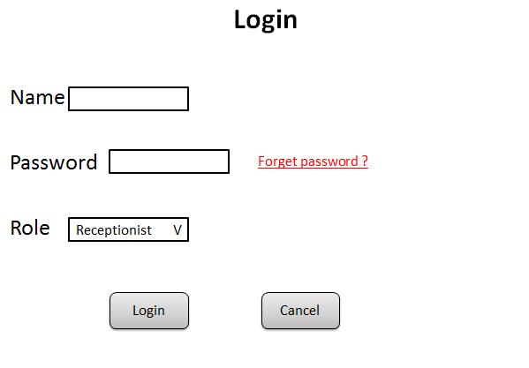
- This is log in page for receptionist, administrator and manager to log into the system, uer can select the role and enter their usename and password.

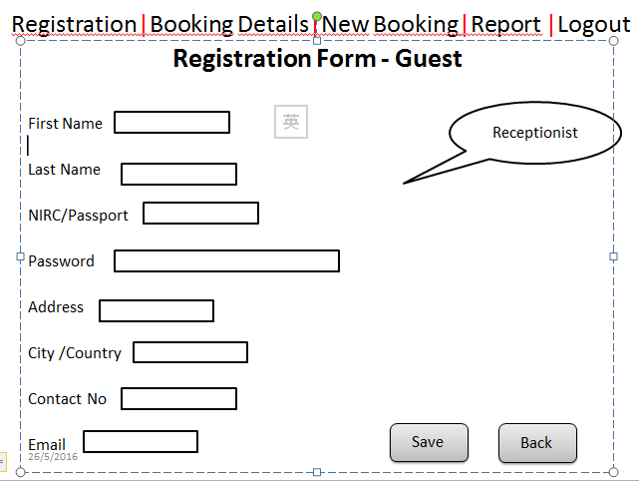
- When receptionist have logged into the system, the function bar will be displayed. This page is regitration for guest, when the guest walk in, receptionist need to register for each guest, the data of each guest will be saved to database, when receptionist books the room for guest, the data will be automatically retrived form the database.
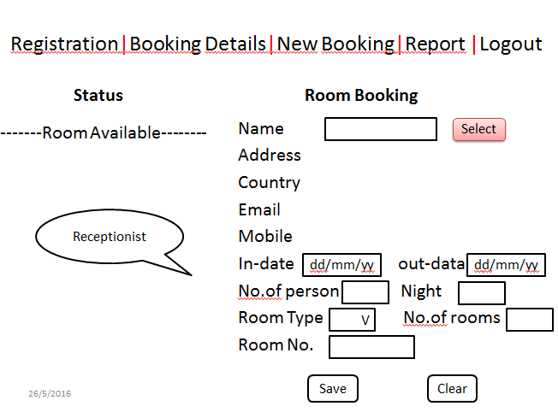
- Receptionist can view the room status whether the rooms are available and create a new booking for guest. The name of the guest need to be select from the database and enter the check-in and check-out date, no of person, how many nights, what kind of room type and how many rooms do they need, after that clicking the “save” button to save the booking.
In addition, administrator and manager can also book the room for the guest.
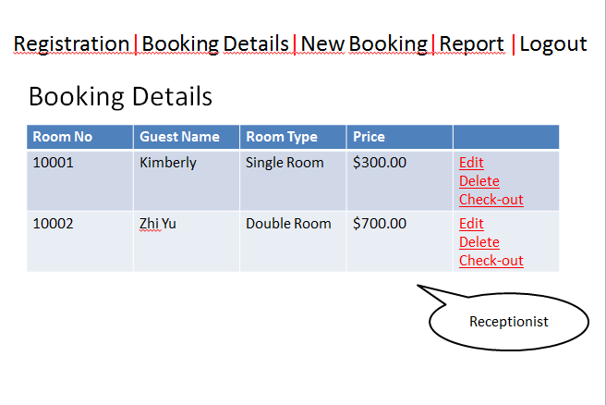
- Receptionist is able to click booking details to view the booking information for each guest, and can edit and delete the booking as well. When the guest is ready to check-out, receptionist can click check-out and turn to bill page.

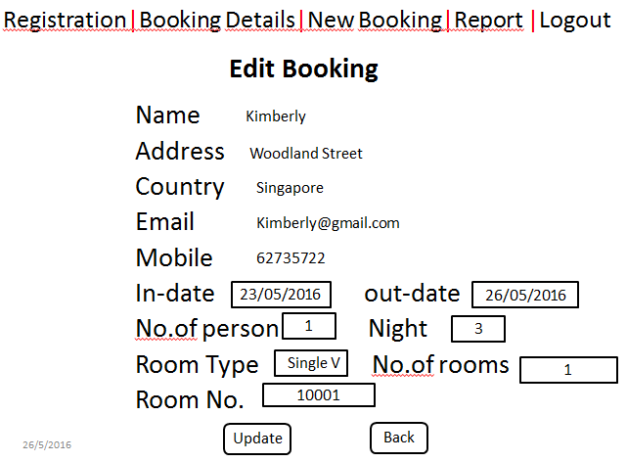

- This page is edit booking page, receptionist can update the booking information for guest.

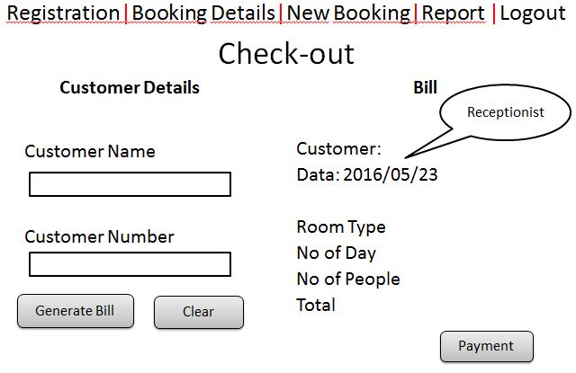

- The check-out page needs receptionist to enter the guest name and guest no to generate the bill, and the bill page will retrieved the information from the database and display the total price to guest to make payment.

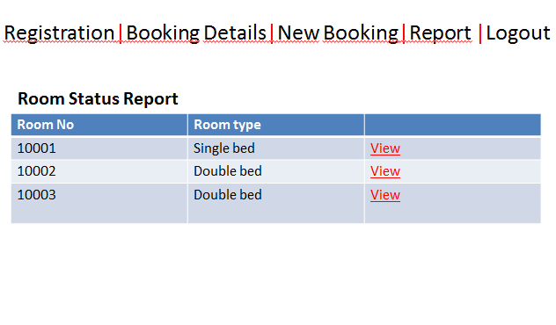

- The receptionist only can view the room status report.

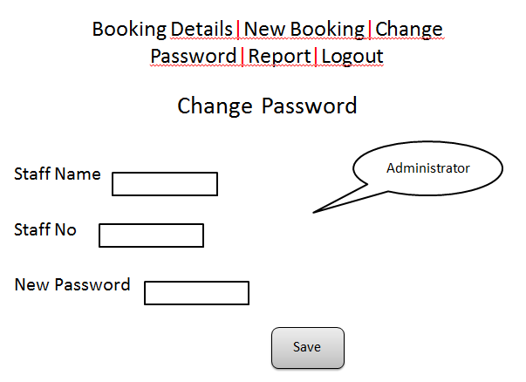

- This page is for administrator to change the password for staff members, just enter the staff name, staff no and new password, clicking “save” button, the password can be change.

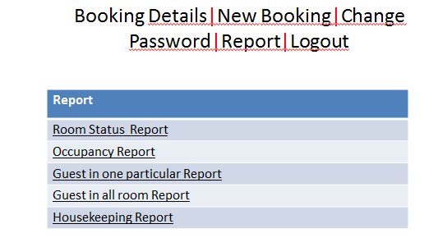
- Administrator and manager can click ”reprot” function from the function bar, the table of each report will be displayed. They can select one of it to view.

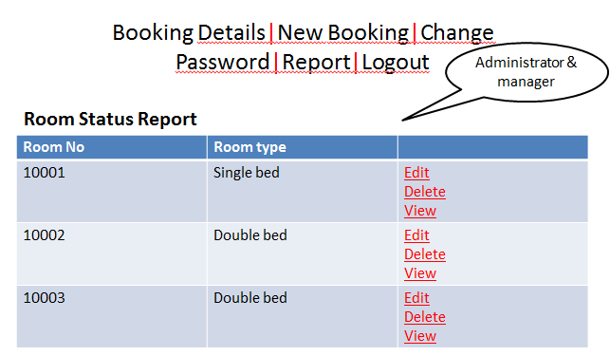

- The administrator and manager can edit, delete and view the room status.

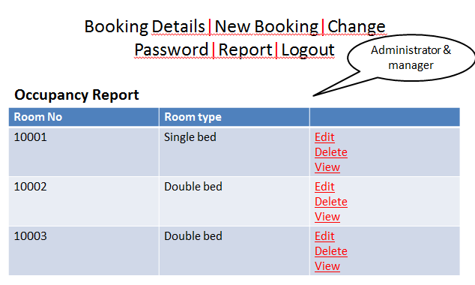

- The occupancy report also can be edited, deleted and viewed by administrator and manger.

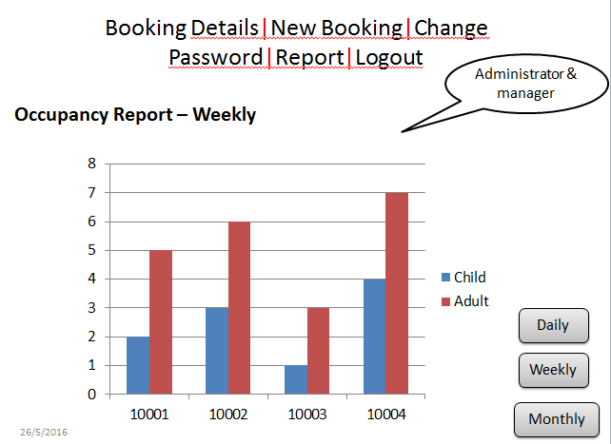

- This is weekly occupancy report showing, administrator and manager can click “daily”, “weekly” and “monthly” button to view each period of the report.

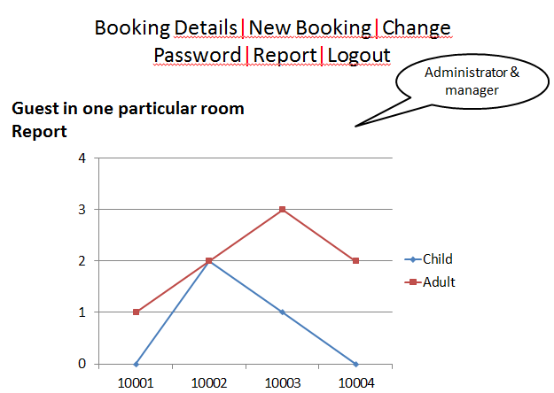

- The guest in one particular room report.

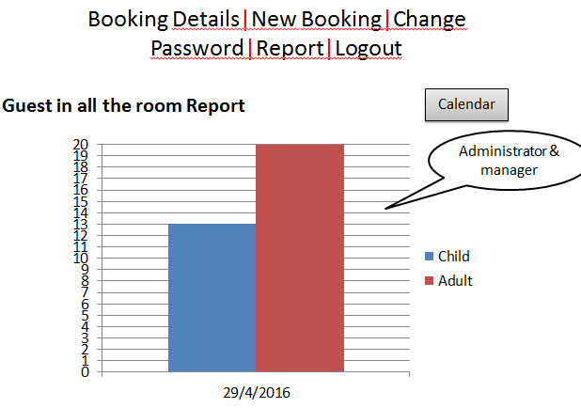

- Administrator and manager can click the “calendar” button to select a date to view the guest in all room report.

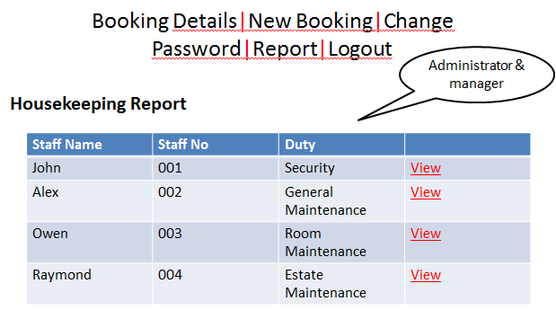

- The housekeeping report provides the duty of each staff.

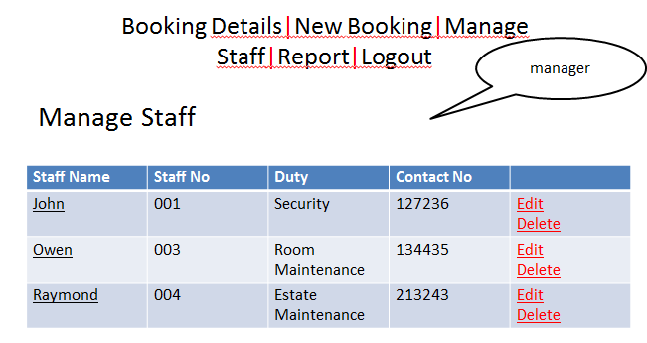

Only the manager can manage the staff to assign the task and edit the staff information or delete the staff.

Interface with Other Systems
Communication Interface
When a specific reservation reserved at the same time an email notification will be sent to guest’s account will be notified in the reservation successfully, check-in date and check-out date. To achieve that functionality, it requires having a stab le internet connection. Mostly a broadband connection with the client’s computer will provide the efficient service.

Public to the internet Interface
Administrator can easily to publish the hotel picture, the good feedback and hotel announcement to internet, such as hotel Facebook, hotel twitter or hotel website for guest to compare and choose the best hotel they want to fare.

Assumptions
- Management will ensure that project team members are available as needed to complete project tasks and objectives.
- Failure to identify changes to draft deliverables within the time specified in the project timeline will result in project delays.
- All software and hardware are in good condition and is available to work on.
- All team members have the skills required for implementing a system. Such as coding and web design.
- The system should be able to run smoothly with all three modules working by the end of eight weeks.
- All the requirements stated by Mr Wang would be met at the end of the project.

OPERATIONAL AND QUALITY REQUIREMENTS

Operating Environment
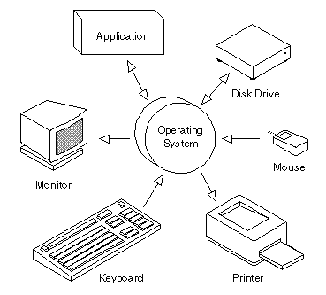
The operating environment that the system will be deployed would be in a single computer which is located at the reception counter of the hotel. The computer is running on pantheon 4 PC.
All standard computer hardware is to be use, such as the monitor, CPU, mouse and keyboard. This system will not be integrating with other application due to the time and budget constraints, thus the operating environment is standard.

Development Constraints

The schedule of 8 weeks is a little tight.

The platform where the system will be deployed is rather old.

We were only given a budget of $70,000

Performance

There is different acceptable system response time for different functions. Users seem willing to wait varying amounts of time for different types of interactions. The amount of time a user is willing to wait appears to be a function of the perceived complexity of the request. For example, people will wait longer for requests they think are hard or time-consuming for the computer to perform.

According to research, users think that 5 second and below is consider very good, 6 to 10 seconds is an average while 10 seconds or more would be too slow. Thus, using this result as a guide, the functions that are used by the public should not take more than 10 seconds

The first function which is room availability and booking module, the response time during average timing should be around 5 second while 10 second if its during peak hours. As this function is mainly use by the public, a faster response time shall be met.

The second function which is housekeeping and staff management module, the response time shall be similar as the first function. However, as it is not commonly used by the public, a longer response time will be tolerable. Thus during average timing should be around 5 to 8 seconds while not more than 15 seconds if its during peak hours.

The third function which is the reporting module would need a slightly longer response time as it needs to gather all the required information to be shown in a list. Therefore, during average timing should be around 10 to 12 seconds while not more than 20 seconds if its during peak hours.

Availability
The system should be designed in such a way that the system is available 24/7 as the hotel are operating 24/7 round the clock every year. Hence, the system in a certain sense should not really go down at all.
System maintenance and backing up of data should be done at first Sunday of every month. It will be done in the wee early morning hours from 2:00am to 3:00am. This is because the hotel non-peak hours are usually fairly late in the night. Backup records are to be kept in the system for 5 years, after which they could be safely discarded or in fact maybe in some related topics.

Security and Access Control Requirements
Receptionist, manager and administrator are able log into the Hotel Management System. Receptionist will have access to the Login, View certain reports and Reservation and Booking subsystems. Manager and administrator will have access to the Room availability and Booking, Housekeeping and Staff Management and Report subsystem. The administrator also can access to the Registration which is for creating new staff account. Access to the various subsystems will be protected by a user log in screen that requires a user name and password.

SPECIAL REQUIREMENTS

Data Archival
Data archiving is the process of identifying and moving inactive data out of current production systems and into specialized long-term archival storage systems. Moving inactive data out of production systems optimizes the performance of resources needed there while specialized archival systems store information more cost-effectively and provide for retrieval when needed.

Automating the data archiving process and using purpose-built archive systems make production systems run better, use less resources, and reduce overall storage costs. Production performance is unaffected by information growth. Backup and recovery runs faster, disaster recovery is less costly, and systems are easier to manage. Data moved into archives is stored at much lower cost.

Exporting data to Excel and Word Doc
Exporting data to excel and word format is easily for administrator and manager to manage the data and print it out. Any report can be export as word doc that will be more efficient to analysis the reports.

REFERENCES

http://www.webopedia.com/TERM/O/operating_environment.html
http://www.humanfactors.com/newsletters/response_times.asp

